DSNI Annual Anti-Doping Report 2024-25
Introduction
Disability Sport NI acts as the “National Governing Body” / Development Agency for the sports of Wheelchair Basketball and Boccia in Northern Ireland. Disability Sport NI is committed to ensuring a Clean Sport environment and we work in partnership with UK Anti-Doping (UKAD), British Wheelchair Basketball and Boccia UK to ensure that the integrity of our sport is protected.
The anti-doping rules of Disability Sport NI are the UK Anti-Doping Rules published by UK Anti-Doping Limited (or its successor), as amended from time to time. Such rules shall take effect and be construed as rules of Disability Sport NI.
UKAD Assurance Framework
In 2021 a new UK National Anti-Doping Policy was introduced, which enables the UK to meet the UNESCO Convention against Doping in Sport. The policies and requirements are driven by the World Anti-Doping Authority (WADA) standards https://www.wada-ama.org/en/what-we-do/international-standards/

UK Anti-Doping (UKAD) published an Assurance Framework that all NGBs must comply with. Disability Sport NI has completed the UKAD assurance framework and demonstrated our compliance with the National Anti-Doping Policy. DSNI has produced a strategy and education and implementation plan to meet the requirements and needs of the framework and we have been working through this plan throughout 2024-25. A Clean Sport Committee was established within DSNI and this committee meets quarterly to review our education and implementation plan and share any updates in relation to anti-doping.
For more details of the assurance framework please visit UKAD’s website here https://www.ukad.org.uk/national-anti-doping-policy/
Board Engagement
Greg Yarnall was appointed the Designated DSNI Board member for Anti-Doping in March 2024. The DSNI board adopted the UK Anti-Doping Rules at the March 2024 board meeting and Anti-Doping is a recurring agenda item at DSNI board meetings. The assurance framework has enabled to Board to discuss anti-doping in relation to the DSNI strategy and implementation plan progress at meetings.
Education
Hosted two Clean Sport Workshops which were delivered by Wendy Henderson for both Wheelchair Basketball and Boccia athletes, coaches and volunteers on the 19th November 2024. 17 athletes across both sports, 9 coaches/volunteers/ DSNI staff attended these workshops. Athletes who were unavailable to attend these workshops were directed to complete the online eLearning courses.
Information on clean sport included in both Academy and DSNI League handbooks across both sports for the 2024-25 season. Athletes are also able to access e-learning, with Clean Sport being promoted at two Wheelchair Basketball NI League Game days and Boccia events throughout the year. Athletes who progress along the Player Pathway, are supported by Great Britain in relation to Anti-Doping information, with training and education occurring in line with the international competition structure.
Two DSNI staff members attended the Commonwealth Games NI information session in relation to Clean Sport and Anti-Doping for the games, delivered by Wendy Henderson.
Communications
We have continued to display our Clean Sport Banners at competition days across both Boccia and Wheelchair Basketball and communicated the updates to the Prohibited List to our athletes.
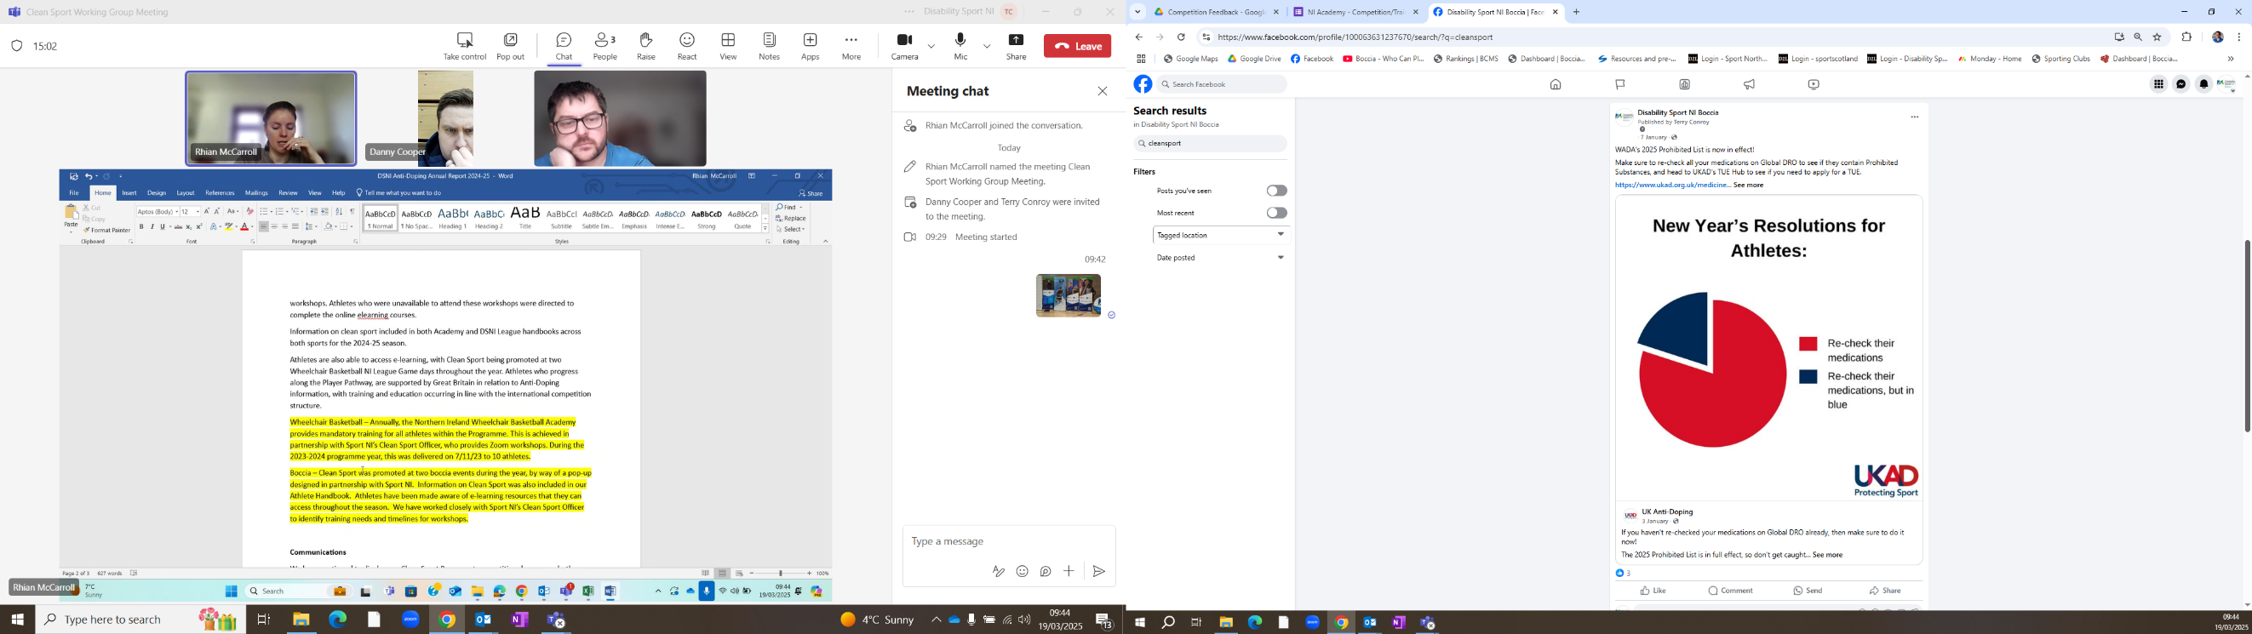
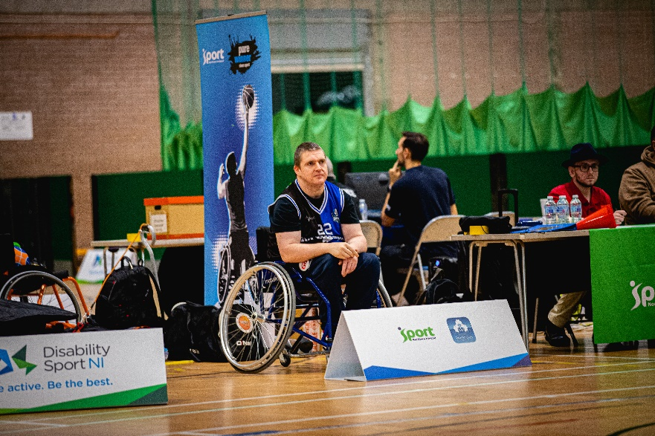
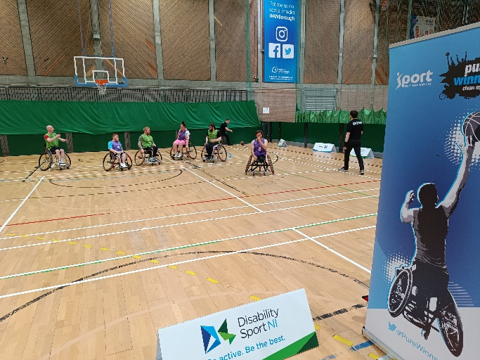
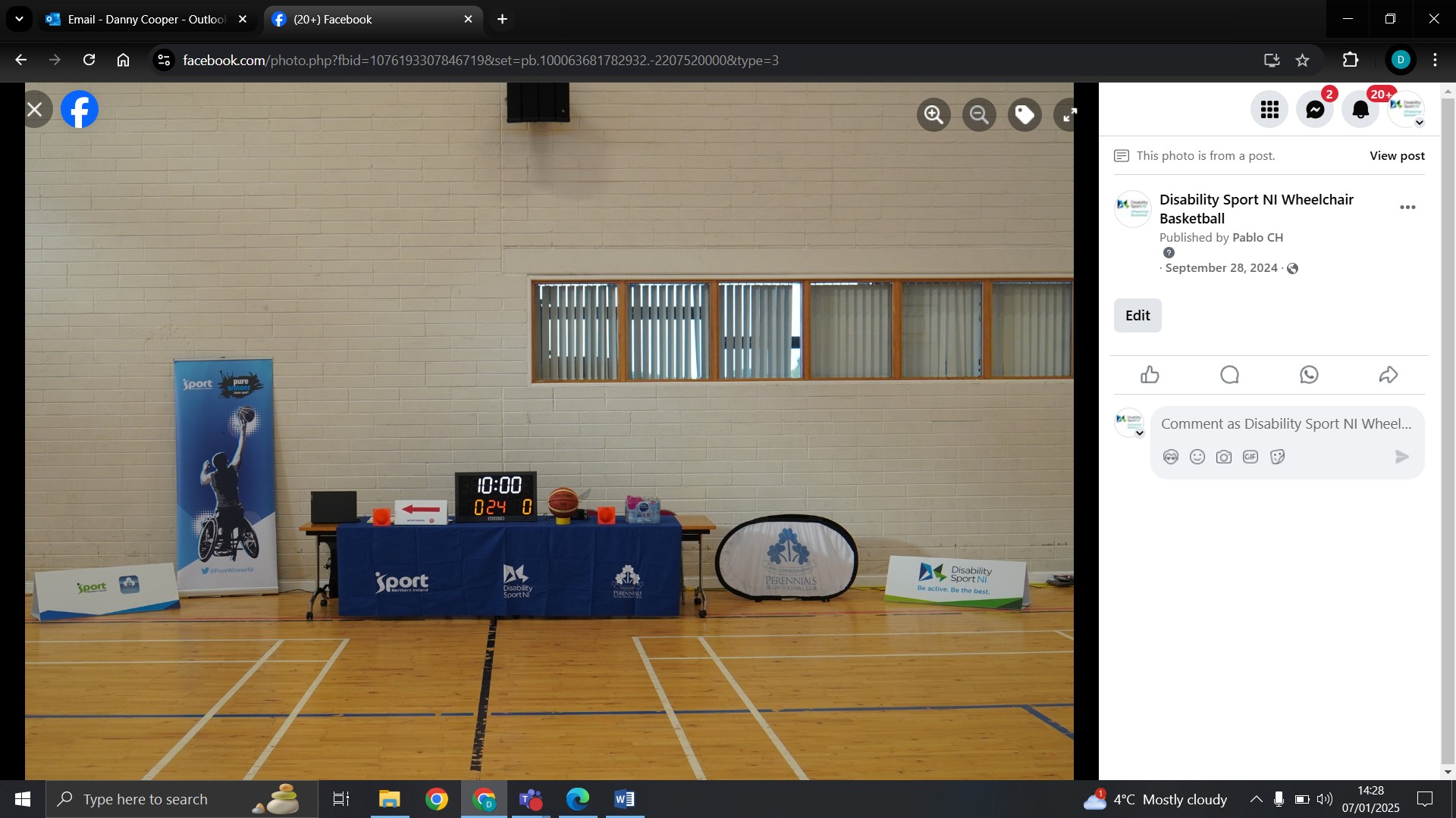

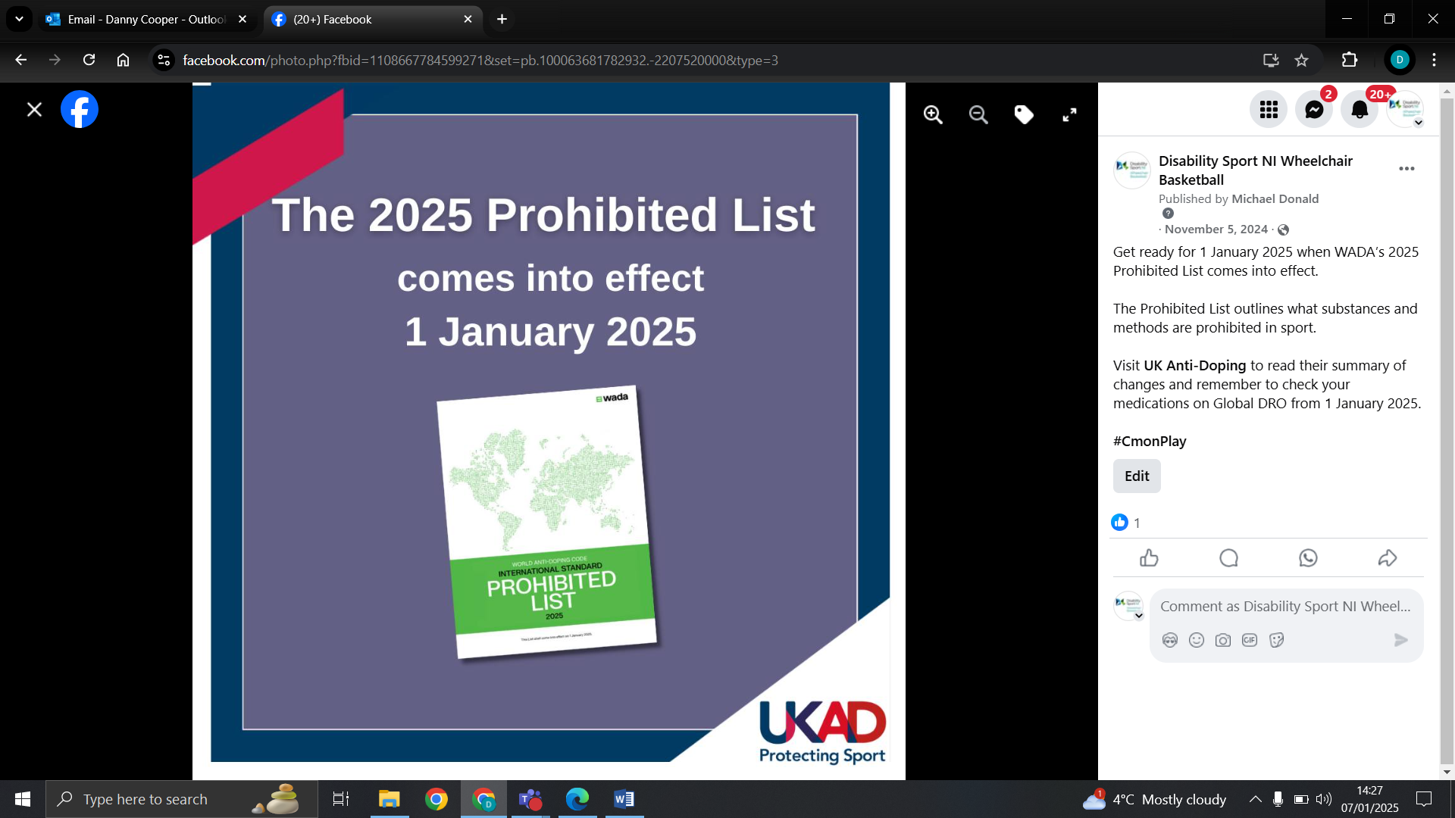

We communicated and supported Clean Sport Week 2024, sharing information with our coaches, clubs and athletes and sharing posts on our social media channels.
